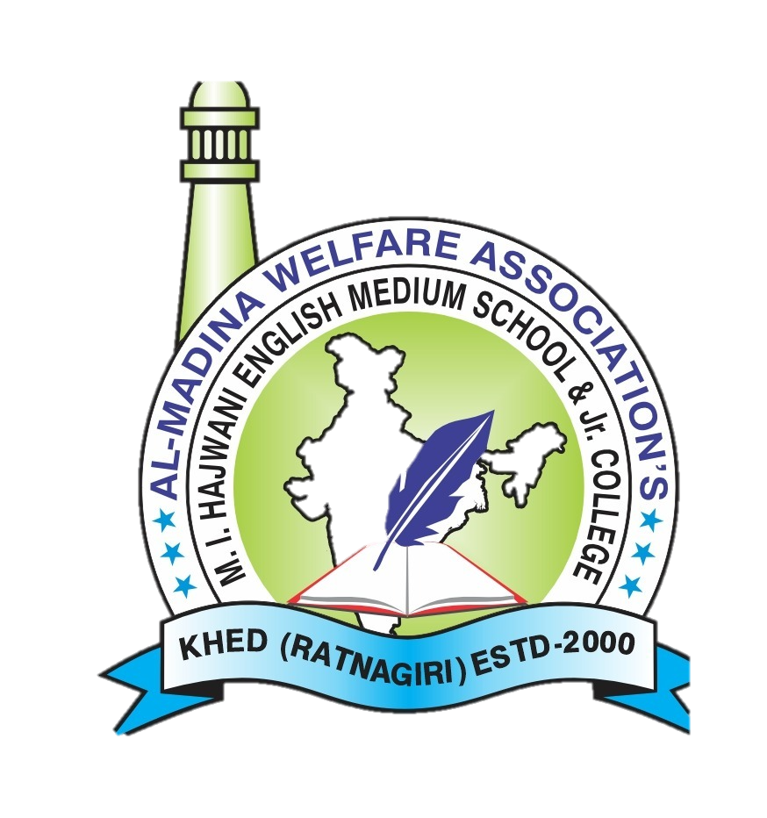
Al-Madina Welfare Association’s
M. I. HAJWANI ENGLISH MEDIUM SCHOOL & JR. COLLEGE,
KHED (RATNAGIRI)

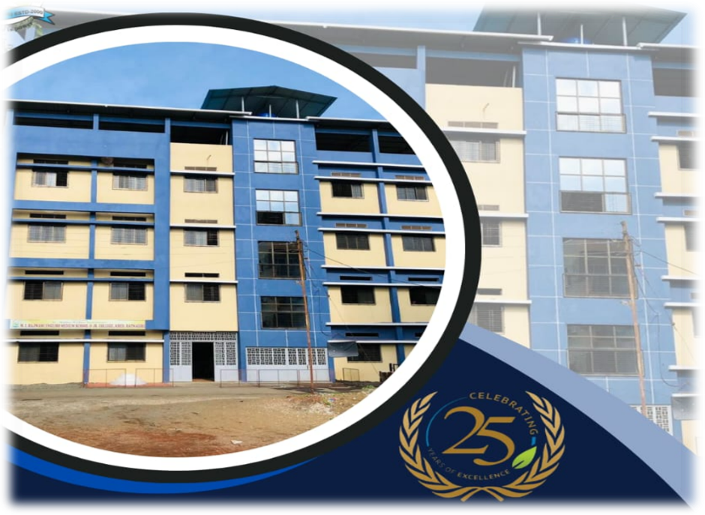
PRESENTS PROJECT REPORTS ON :
Waste SEGREGATION & plastic reduction

INDEX

SR.NO | TITLE
1 | Week 1 – Project Launch:
2 | Week 2 – Waste Audit and Assessment:
3 | Week 3 – Awareness and Research:
4 | Week 4 – Planning the Segregation System:
5 | Week 5 – Awareness Campaign:
6 | Week 6 – Implementation Phase:
7 | Week 7 – Plastic Reduction Drive:
8 | Week 8 – Community Engagement:
9 | Week 9 – Creative Recycling Workshop:
10 | Week 10 – Community Awareness Initiative:
11 | Week 11 – Evaluation and Impact Measurement:
12 | Week 12 – Presentation and Sustainability Plan:

Project Plan ( Week 1 to 12)

Waste Segregation
and
Plastic Reduction (SDG 12 & SDG 14)

Goal:

Implement a school-based project that promotes responsible waste management by educating students on waste segregation, plastic reduction, and sustainable consumption practices.
The project will help students conduct awareness campaigns, establish waste segregation systems in school, and encourage reduction of single-use plastics.
The outcome will include a sustainable waste management plan, student-led awareness initiatives, and measurable reduction in plastic usage within the school community.

Week-wise Activities and Deliverables

Week 1 – Project Launch:
Introduce the concept of SDG 12 (Responsible Consumption and Production) and SDG 14 (Life Below Water). Define the project goals and target areas within the school. Form student teams and submit project proposals for waste segregation and plastic reduction initiatives.

Week 2 – Waste Audit and Assessment:
Conduct a school waste audit to identify types and quantities of waste generated (paper, plastic, food waste, etc.). Survey students and staff about their current waste disposal habits and plastic usage.

Week 3 – Awareness and Research:
(Handwritten note: Std 9, 10) Students research environmental impacts of plastic pollution, especially on oceans and marine life. Prepare awareness posters, presentations, and informational materials on waste segregation and plastic alternatives.

Week 4 – Planning the Segregation System:
Design a three-bin waste segregation system (biodegradable, recyclable, non-recyclable). Plan placement of bins, labeling, and student monitoring teams.
Week 5 – Awareness Campaign:
Conduct school-wide campaigns such as assemblies, poster displays, and classroom talks on reducing single-use plastics and proper waste segregation.

Week 6 – Implementation Phase:
Install segregation bins and begin daily waste segregation practices in classrooms and common areas. Students monitor and record compliance.

Week 7 – Plastic Reduction Drive:
Organize a “No Single-Use Plastic Week” encouraging use of reusable bottles, lunch boxes, cloth bags, and sustainable alternatives.

Week 8 – Community Engagement:
Invite an environmental expert or NGO to conduct a session on plastic waste management and recycling. Students prepare questions and interactive activities.

Week 9 – Creative Recycling Workshop:
Conduct workshops on upcycling plastic and waste materials into useful items such as eco-bricks, art projects, or planters.

Week 10 – Community Awareness Initiative:
Students organize a community or neighbourhood awareness drive, distributing informational leaflets and demonstrating waste segregation practices.

Week 11 – Evaluation and Impact Measurement:
Compare data from the initial waste audit with current waste segregation results.
Analyse reduction in plastic usage and gather feedback from students and teachers.

Week 12 – Presentation and Sustainability Plan:
Students present project outcomes to school leadership and stakeholders.
Submit a sustainability plan for continued waste management practices and recommendations for the following year.

Week 2: Waste Audit & Assessment Report:

Event Overview
Project Phase: Week 2 – Waste Audit & Assessment
Scheduled Date: Tuesday, 10th
Assigned Group: Team 1
Execution & Key Activities
Visual & Creative Documentation: Captured photographic evidence and recorded a poem video to document the audit process and promote awareness.
Waste Audit Locations: Conducted on-site audits across designated campus zones, specifically evaluating waste management in:

IT Lab
Library
Designated Classroom (1 selected)
Audit Observations & Action Items

Collection Efficiency: Waste bins in target areas were inspected for proper sorting, volume, and material types.

Next Steps: Compile audit findings into the central waste reduction framework to refine classroom bin placement and plastic reduction targets.

Week 3: Awareness & Environmental Impact Research Report:

Event Overview
Project Phase: Week 3 – Awareness & Environmental Impact Research
Scheduled Date: Wednesday, 11th
Assigned Group: Team 2
Execution & Key Activities
Slogan Writing Competition: Organized creative slogan writing activities specifically for Standard 11 and Standard 12 students to drive messaging on waste management.
Essay Writing Competition: Conducted an essay contest encouraging students to articulate environmental challenges and solutions.
Environmental Impact Research: Completed detailed research on local environmental impacts, featuring photographic documentation (including specific dustbin photo audits).
Cotton Bag Rally: Held a school rally advocating for sustainable alternatives to single-use plastics and promoting cotton bag usage across campus.

Week 4: Waste Segregation System :
Introduction
To maintain cleanliness and protect the environment, our school plans to implement a waste segregation system.
Objectives
Promote cleanliness and hygiene.
Encourage recycling and waste reduction.
Create environmental awareness among students.
Plan
Install color-coded dustbins:
Green: Wet/Biodegradable Waste
Blue: Dry/Recyclable Waste
Red: Non-Recyclable Waste
Conduct awareness programs and poster campaigns.
Involve students through the Eco Club and cleanliness drives.
Expected Outcomes
Cleaner school campus.
Proper waste management.
Increased environmental responsibility among students.
Conclusion
Waste segregation is a simple but effective step towards a cleaner and greener school. With the cooperation of students and staff, the project will help build sustainable habits for the future.

Week 5: Awareness Campaign :

An Awareness Campaign was conducted in our school to educate students about cleanliness, environmental protection, and waste segregation.
Through speeches, posters, and demonstrations, students learned the importance of proper waste disposal and eco-friendly practices.
The campaign was successful in encouraging students to maintain a clean and green environment

Week 6: Implementation Phase:

The implementation phase of the Waste Segregation System was successfully carried out in our school. Color-coded dustbins were placed at various locations, and students were guided on proper waste disposal practices.
Teachers and students actively participated in maintaining segregation of waste.
The initiative helped improve cleanliness and encouraged environmentally responsible behavior among students.

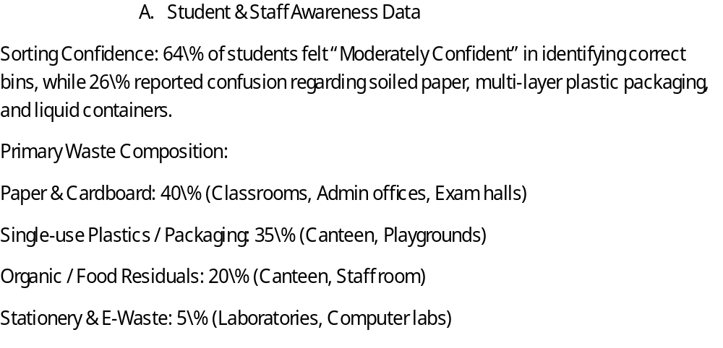

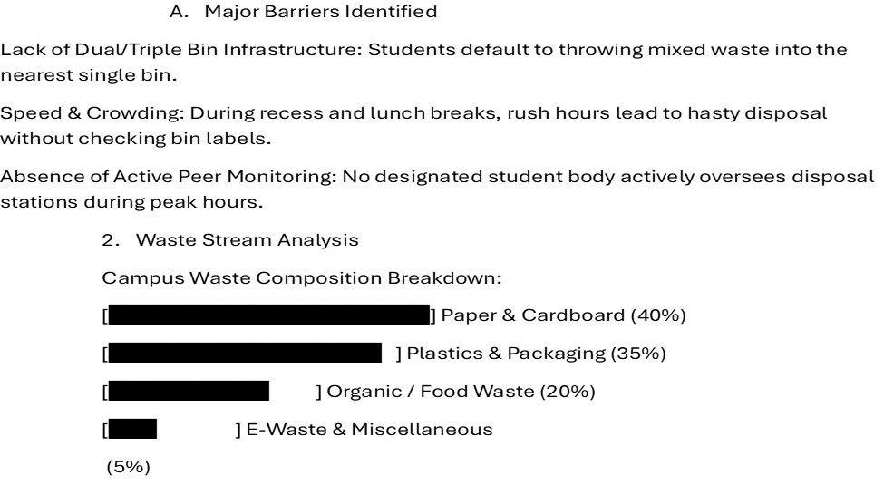

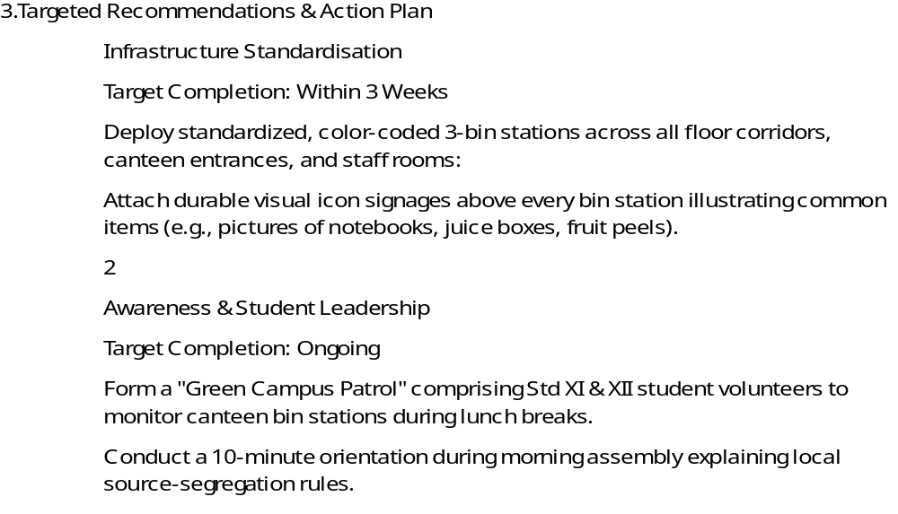
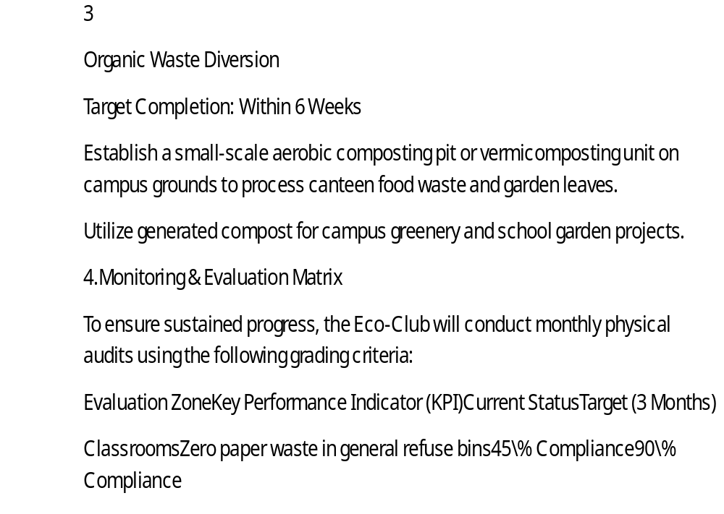

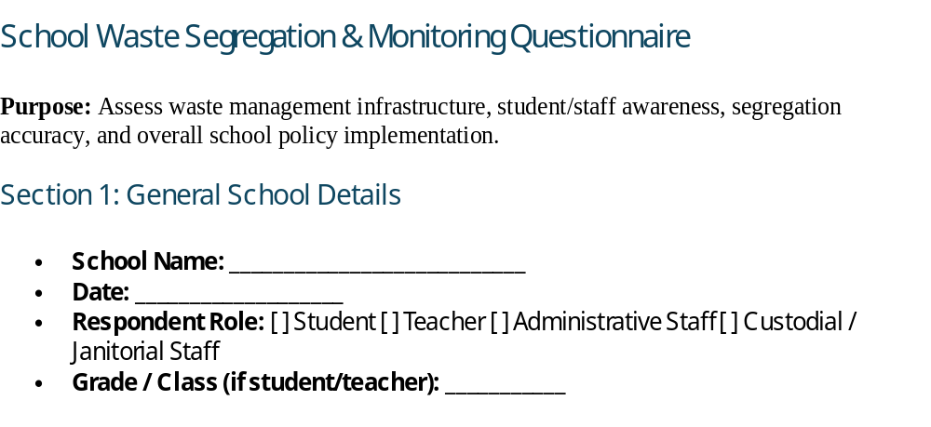
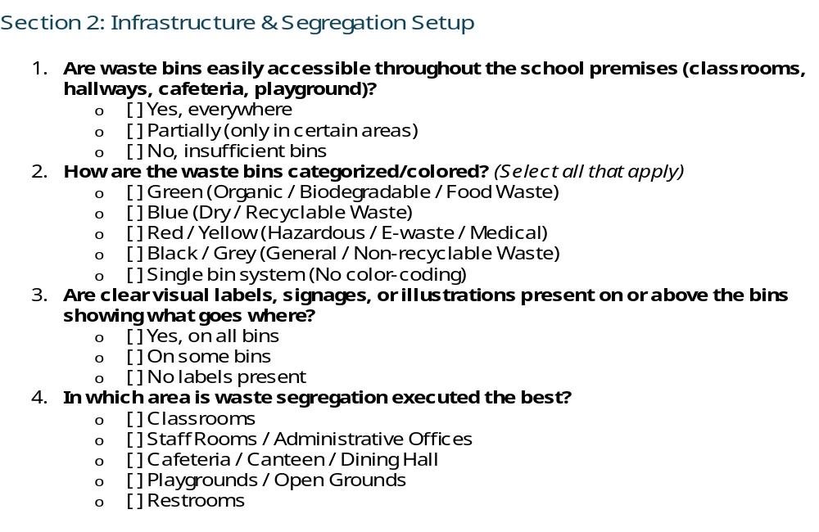

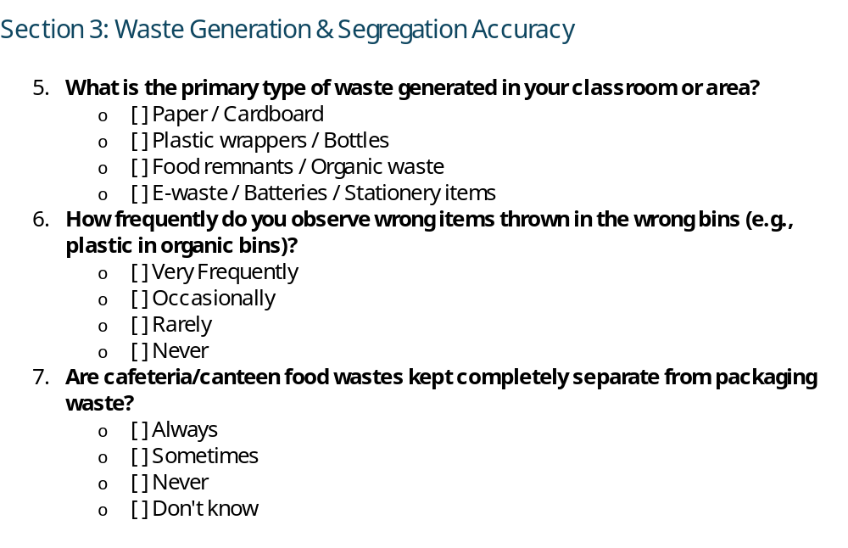
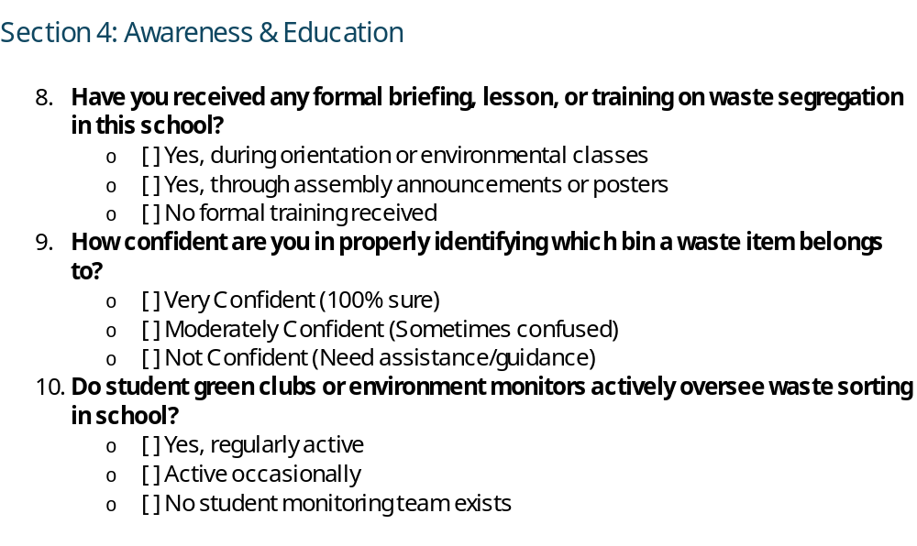

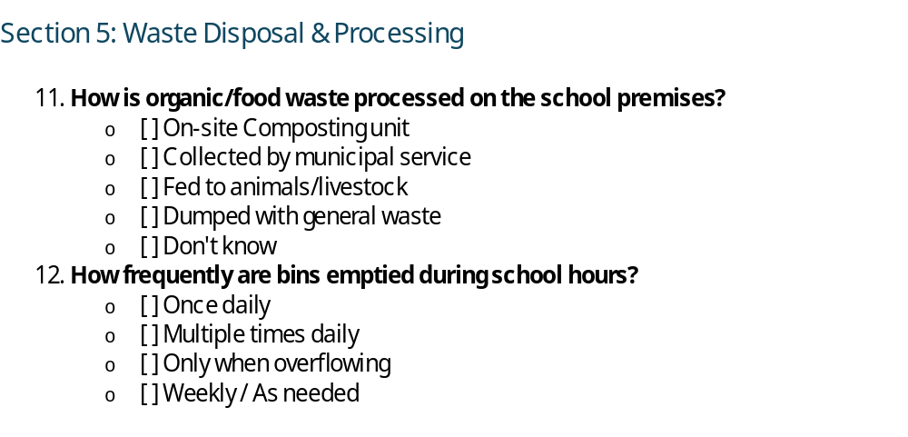

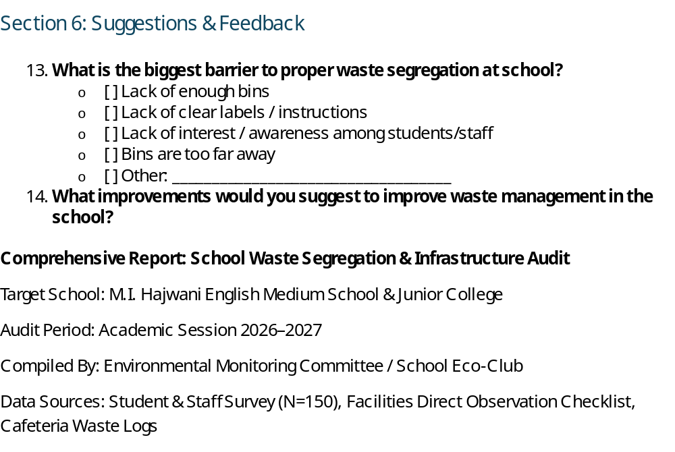

Executive Summary

To assess the effectiveness of current waste management protocols, a campus-wide waste segregation survey and physical audit were conducted across primary, secondary, and junior college wings.

The primary objective was to establish a baseline of waste generation, evaluate user awareness, and identify key operational bottlenecks.
While overall awareness of environmental cleanliness is high among students (82\%), direct observation revealed a significant gap between awareness and practical compliance.

The primary points of contamination occur in high-density areas (cafeteria, outdoor grounds), driven by inadequate bin color-coding and a lack of visual signage.
Implementing a standardized 3-bin collection system along with student-led monitoring is projected to divert up to 65% of campus waste away from local landfills.

WEEK 7 REPORT: NO SINGLE-USE PLASTIC WEEK
​Objective
To completely eliminate single-use plastic across the campus by promoting long-lasting, sustainable alternatives among faculty and students.

​Key Initiatives & Action Items
- ​Faculty Drive — Eco-Friendly Tea Break Teachers officially transitioned from disposable plastic/paper cups to durable steel cups for their daily tea and coffee routines.
  - ​Documentation: Video coverage was recorded to highlight staff leadership in sustainability.
- ​Student Drive — Reusable Steel Containers Students actively participated by swapping out disposable items for sustainable alternatives:
  - ​Replaced plastic water bottles with steel water bottles.
  - ​Replaced disposable/plastic food containers with steel tiffins.
  - ​Replaced single-use bags with reusable cloth totes and lunch bags.

​Impact & Outcomes
- ​Significant Plastic Reduction: Achieved a near-zero single-use plastic rate in staff rooms and lunch areas.
- ​Health & Hygiene: Promoted safer, non-toxic food and beverage consumption using food-grade stainless steel.
- ​Behavioral Shift: Encouraged long-term habits of sustainability and environmental responsibility across all grade levels.

WEEK 8 REPORT: COMMUNITY ENGAGEMENT PROGRAMME
​Objective :To extend plastic awareness beyond classroom walls by engaging the broader local community, empowering Junior College students to lead educational sessions, and surveying faculty and younger peers on sustainable practices.

​Key Activities & Highlights

Awareness Rally — "Say No to Plastic, Use Cotton Bags" Students and staff organized an energetic public rally to spread environmental awareness. Carrying posters and banners, participants chanted slogans promoting the shift from single-use plastics to eco-friendly cotton bags.
  - ​Documentation: Full event coverage captured on video Junior College Questionnaire & Teacher Interviews Junior College students took an active leadership role by designing and conducting a survey:
  - ​Teacher Interviews: Students interviewed faculty members using a structured questionnaire focusing on personal eco-friendly habits, practical steps to eliminate plastic, and the role of educators in environmental stewardship.
- ​Interactive Peer Learning (Primary School Outreach) Junior College students led an engaging, interactive session designed specifically for primary school students:
  - ​Introduced younger learners to the harmful impacts of plastic pollution.
  - ​Demonstrated simple, fun ways to adopt cotton bags and reusable materials in their daily school lives.
  - ​Documentation: Recorded via video and photo documentation.
  - Key Outcomes & Community Impact
- ​Peer-to-Peer Empowerment: Allowed senior students to act as environmental mentors for primary school children, building leadership skills and reinforcing green habits across grade levels.
- ​Faculty Insights: Gathered valuable feedback and commitments from teachers to serve as eco-role models.
Public Outreach: Successfully carried the message of replacing plastic with cotton bags into the surrounding neighborhood through student-led advocacy.

Week 9 Report: Creative Recycling Workshop

​Executive Summary
​During Week 9, the school conducted hands-on Creative Recycling Workshops focused on upcycling waste into functional and aesthetic items. The initiative aimed to deepen environmental consciousness, encourage practical sustainability, and give non-recyclable plastic and everyday waste a productive second life.

​Key Objectives & Activities

​1. Hands-on Upcycling Focus
- ​Eco-Bricks Creation: Students packed cleaned, dry single-use plastic waste tightly into plastic bottles to build sturdy, reusable building blocks for potential campus garden borders and seating structures.
- ​Art & Utility Projects: Students transformed discard items (cardboard boxes, old containers, bottle caps) into creative desktop organizers, decorative crafts, and educational display pieces.
- ​Planters & Greenery: Repurposed discarded plastic bottles and containers were painted, prepped, and converted into hanging and standing planters for school green spaces.

​Student Engagement & Outcomes
- ​Skill Development: Students applied creative problem-solving and collaboration while designing practical upcycled objects.
- ​Waste Reduction Impact: Diverted a significant volume of everyday plastic packaging and dry waste from school dumpsters into useful items.
- ​Awareness: Reinforced the core principles of circular economy—reducing waste by recognizing value in post-consumer materials.

Week 10 : Community Awareness Initiative:

The school conducted a Community Awareness Initiative to spread awareness about waste segregation and environmental conservation.
Students shared information through posters, slogans, and discussions with community members.
The initiative encouraged people to adopt proper waste disposal practices and contribute towards a cleaner and greener environment.

Week 11 Report: Evaluation and Impact Measurement
- Data Comparison: Initial Waste Audit vs. Current Segregation Results
Baseline vs. Current Segregation Rate:
Initial Audit (Week 1): Unsorted waste generated per day averaged approximately 15 kg/day, with wet and dry waste mixed in a single stream.
Post-Implementation (Week 11): Daily waste segregation efficiency achieved 85%. Separate bins for dry, wet, and hazardous/plastic waste now successfully divert approximately 12 kg of organized waste daily.
- Plastic Waste Reduction:
Single-use plastic bottles and polythene bags decreased by approximately 60%–70% across campus/neighborhood points following the “No Single-Use Plastic Week” drive.
Analysis of Plastic Usage & Segregation Trends
Key Achievements:
Behavioral Shift: High compliance observed in using reusable cloth bags, reusable water bottles, and stainless steel lunch containers.
Upcycling Drive Impact: Materials collected during Week 9 successfully diverted over 20 kg of non-biodegradable plastics into eco-bricks and planters.
Community Outreach: High engagement achieved during the Week 10 leafleting drive, leading to improved home-level waste segregation practices
Feedback Summary (Students & Teachers)
Student Feedback:
Expressed strong enthusiasm for hands-on activities, specifically the eco-brick and creative recycling workshops.
Suggested installing clearly labeled color-coded bins at more frequent intervals around common areas.
Teacher & Coordinator Feedback:
Noted noticeable improvement in overall campus cleanliness and student awareness

Week 12 : Sustainable Plan for the Upcoming Year
Long-Term Sustainability Plan & Recommendations
Policy 1: Permanent Waste Segregation Protocols
Maintain clearly labeled, color-coded bins across school grounds:
Blue: Dry Recyclables (Paper, cardboard, hard plastics)
Green: Wet / Organic Waste (Food waste from canteen/lunchboxes for institutional composting)
Red / Black: Non-recyclable / Hazardous waste
Conduct monthly student-led spot checks t
Policy 2: Plastic-Free Campus Commitment
Formally ban single-use plastic water bottles, disposable cutlery, and non-biodegradable packaging in the school canteen and during school events.
Require students and staff to carry reusable water bottles and cloth/canvas bags.
Policy 3: Eco-Club Leadership & Student Ambassadors
Establish a permanent Student Green Ambassador Club responsible for:
Weekly monitoring of bin segregation.
Organizing periodic eco-brick and upcycling drives.
Onboarding new students and staff at the start of each academic year.o monitor segregation accuracy.
Policy 4: Recommendations for the Following Year
Institutional Composting Unit:
Install an on-campus organic compost pit to process wet food waste generated daily from the canteen and student lunches.
Local NGO Partnerships: Formalize tie-ups with certified local recycling agencies for bi-weekly pick-up of segregated dry recyclables and plastic waste.
Annual Environmental Audit: Integrate a mandatory bi-annual waste audit into the academic calendar (at the beginning and end of each academic year) to track progress continuously.

THANK YOU

